**Lovestuck Academy Documentation**

By Nicholas Chua Jay Ngan year 13

Alpha 2 footage https://www.youtube.com/watch?v=0D1orIK3Clw

**Standard 3.7**

**Initial Aim**

Create a game in the genre of visual novel and dating simulator.

3 Heroines with linear and separate stories that don’t impact each other.

Simple and limited controls using number keys.

**Target Audience**

Lonely gamers and anime enthusiasts who have reasonable knowledge in games/otaku culture.

**Tests**

|  |  |  |  |  |
| --- | --- | --- | --- | --- |
| **Expected Tests** | | | | |
| Area | Testing | Expectation | Problem/Bug | Solution |
| Menu | Confirm Newgame(save exists) | Opens the confirmation screen when there isn’t a save file |  |  |
| Text Display | Going to the next page by pressing 1 | The next page of text displays |  |  |
| Choice Event | Choosing given choices | The selected choice loading its corresponding event. |  |  |
| “Introduction” Scene | Navigation | By pressing 1 or 2 the user can progress through the scene until the end where it loads the “FirstDay” scene. | Does not load the “FirstDay” scene at the end. | Delete an unnecessary method that caused an issue which stops the scene from loading. |
| “First Day” Scene | Playing through a scene | Scene progresses to a choice event and then ends after the selected event runs its course | Text is skipped | Set the choice event to trigger at the right page. |
|  | Playing through a scene | Scene progresses to a choice event and then ends after the selected event runs its course |  |  |
| “First Day” Scene | Playing through a scene. | Changes scene when the player reaches the end of the scene. | "index was outside of bounds of array" error appears | Write code preventing the "index was outside of bounds of array" error |
| Code preventing "index was outside of bounds of array" error | Getting to the end of the text array and going one step further. | No error message occurs and scene changes. | Error message still appears. | Add -1 to the condition codes to account for the 0 elements. |
| “First Day” Scene | Choosing the 4th option. | Goes into the 4th event. | Goes into the 1st event | Set the element where the event trigger happens to element 10 and set a delay to prevent a key press from triggering twice. |
| “First Day” Scene | Choosing the 4th option. | Goes into the 4th event. | Goes into the 1st event | Rework the system: eliminating bools and changing the method to work with array length instead. |
| “First Day” Scene | Choosing the 4th option. | Goes into the 4th event. |  |  |
| Homeroom | Choice text display. | Text changes based on bools in “Save” | NullReferenceException object not set to an instance of an object.  Nothing displayed. | Fix a reference pathway error. |
| Homeroom | Choice text display. | Text changes based on bools in “Save” |  |  |
| Homeroom | 4) Keep to yourself | Goes into the classes event | Nothing happens | Write code for the option. |
| Homeroom | 4) Keep to yourself | Goes into the classes event |  |  |
| Image System Text | Progress through a scene. | Images change as the page number reaches the set points. | NullReferenceException object not set to an instance of an object.  All images are displayed at once | Fixed and added references to the correct places. |
| Image System Text | Progress through a scene. | Images change as the page number reaches the set points. |  |  |
| Image System Text | Progress through a scene | Images are displayed and change when they are set to. | Images cover the text box. | Make the image system a child of the text system so it no longer covers it. |
| Classes | Enter the “Classes” scene. | A random remark is chosen from the array and displayed. |  |  |
| Classes | Go to the next scene | Goes the next scene which is determined by the “lunchCount” int from the save file. |  |  |
| Image System Choice | Choose events | Loads the correct images for each event. | Starting event images do not disappear | Make it so that starting events disappear when the first chosen event image loads |
| Image System Choice | Choose events | Loads the correct images for each event. |  |  |
| Elevator | Press 2 | Loads the “Club1st” scene | Loads “ShiroMeet” scene instead. | Change the name of the scene loaded from “ShiroMeet” to “Club1st” |
| Elevator | Press 1 | Loads the “Home” scene | Doesn’t load it. | Write the code that wasn’t previously there to load the “Home” scene. |
| “EloraMeet” | Progress through the scene, choosing the 2nd choice. | Loads the correct text from the 2nd array and displays the images corresponding to it. | Can’t end the scene as the text is stuck on the 2nd last page. | Fix an if condition that works to stop errors for the choice event but stops the scene from ending. |
| Classes(updated version) | Press space | Chooses a random page from the array. | Nothing happens | Added a missing “page =” in the code. |
| Save | Exit to the menu and use continue. | Goes to the beginning of the last scene you were on. | Goes to the “Introduction” scene. | Have a different script execute the method to load the last scene. Save the name of the scene constantly to avoid and Unity mishaps. |
| Save | Exit to the menu and use continue. | Goes to the beginning of the last scene you were on. |  |  |
| Affection System | Go through a scene that adds affection points at the end. | Affection points are added and the value carries over to the next scene. | Affection points and other save data does not carry over. | Set the correct path for a script when accessing the save file. |
| Affection System | Go through a scene that adds affection points at the end. |  |  |  |
| Continue | Exit a scene to the menu, go to either “Lore” or “Affection”, return to the menu and return to the scene by going to continue. | Loads the menu then the desired scene, then the menu and back to the scene exited in the first place. | Does not load the scene exited in the first place. | Put a condition where the scene name is not recorded when the scene is named “Menu”, “Lore” or “Affection” |
| Continue | Exit a scene to the menu, go to either “Lore” or “Affection”, return to the menu and return to the scene by going to continue. | Loads the menu then the desired scene, then the menu and back to the scene exited in the first place. |  |  |
| Save | Go to a one-off scene | Save file records the visit to the one-off scene | Save file does not record the visit to the one-off scene. | Write the code that was missing to actually record the visit. |
| Save | Go to a one-off scene | Save file records the visit to the one-off scene |  |  |
| Classes | Progress through the scene. | Loads a lunch scene based on the “lunchCount” int in save at the end of the scene. | Does not load any scene. | Fixed mistakes with the dictionary values used to load the scene. |
| Classes | Progress through the scene. | Loads a lunch scene based on the “lunchCount” int in save at the end of the scene. |  |  |
| Lunch | Go through the “Classes” scene multiple times. | A new lunch scene is loaded each time. |  |  |
| Elevator | Visit the “ShiroMeet” scene and reach the “Elevator” scene. | “Talk to the girl with cat ears” becomes “2)Club” |  |  |
| Elevator | Press two after unlocking “2)Club” | Goes to the Club1st scene. |  |  |
| Classes | Press space | A random page is chosen. | Nothing happens | Fix the max and min values the random integer could take. |
| Classes | Press space | A random page is chosen. |  |  |
| **Boundary Tests** | | | | |
| Choice Event | Selecting the highest number choice | It loads the corresponding event. |  |  |
| Image System Text | Set certain images to trigger at a page number is less than 0 so that they don’t appear. | The images not supposed to appear don’t and the scene progress normally. |  |  |
| Image System Text | Set certain images to trigger at a page bigger than the maximum page number. | The images not supposed to appear don’t and the scene progress normally |  |  |
| Pressing Space | Hold the space bar | Goes to the next page once |  |  |
| “lunchCount” reset | End the “Classes” scene 8 times. | The next lunch scene will be the second lunch scene again as there are no more new lunch scenes. |  |  |
| **Unexpected Tests** | | | | |
| Introduction | Press one and two and the same time | Scene progresses normally |  |  |
| Choice Event | Trying to select choices not given by pressing 3 and 4 when there are only 2 choices | Nothing happens |  |  |
| Image System Text | Set all images to trigger at the same scene | The only images that appear are “Back3” and “Girl6” |  |  |
| Image System Text | Set images designed to appear later on first and the first images to appear later | Later images do not disappear when the first images appear. |  |  |
| Image System Text | Go through a scene normally | The correct images load. | Text boxes and other UI are covered by the image system canvas. | Make the image system a child of the main UI canvas. |
| Affection Point System | Repeatedly exiting and entering a scene which starts it all over from the beginning. | This allows the player to repeatedly farm affection points as affection points are given at the start of the scene for text only events and when a choice is made for choice events. |  | Set it so that affection points are only awarded just as the scene changes |
| Pressing space | Press the space bar rapidly | Goes to the next page multiple times |  |  |
| Pressing space + choice | Press the space bar during a choice event | Nothing happens |  |  |
| Lore | Press one and two at the same time | The single key press registered by the computer first carries out the corresponding method or nothing happens as both key presses are registered |  |  |
| Elevator | Choose unavailable options.  (Options are available after talking to heroines.) | Nothing happens. |  |  |
| Affection Viewing Scene | Press random keys | Nothing happens |  |  |
| Affection Viewing Scene | Click random things | Nothing happens |  |  |

**Credits**

Programming and Sprites by Nicholas Chua

Referenced code from Josh Browne and Aidan Diprose.

The free for commercial use font was ‘**7:12 Serif Font’** by Christian Munk <https://christianmunk.1001fonts.com/>

**Standard 3.8**

**Planning** was done in LovestuckAcademy.docx

**Target Audience**

Lonely gamers and anime enthusiasts who have reasonable knowledge in games/otaku culture.

**Project management** was done with Trello

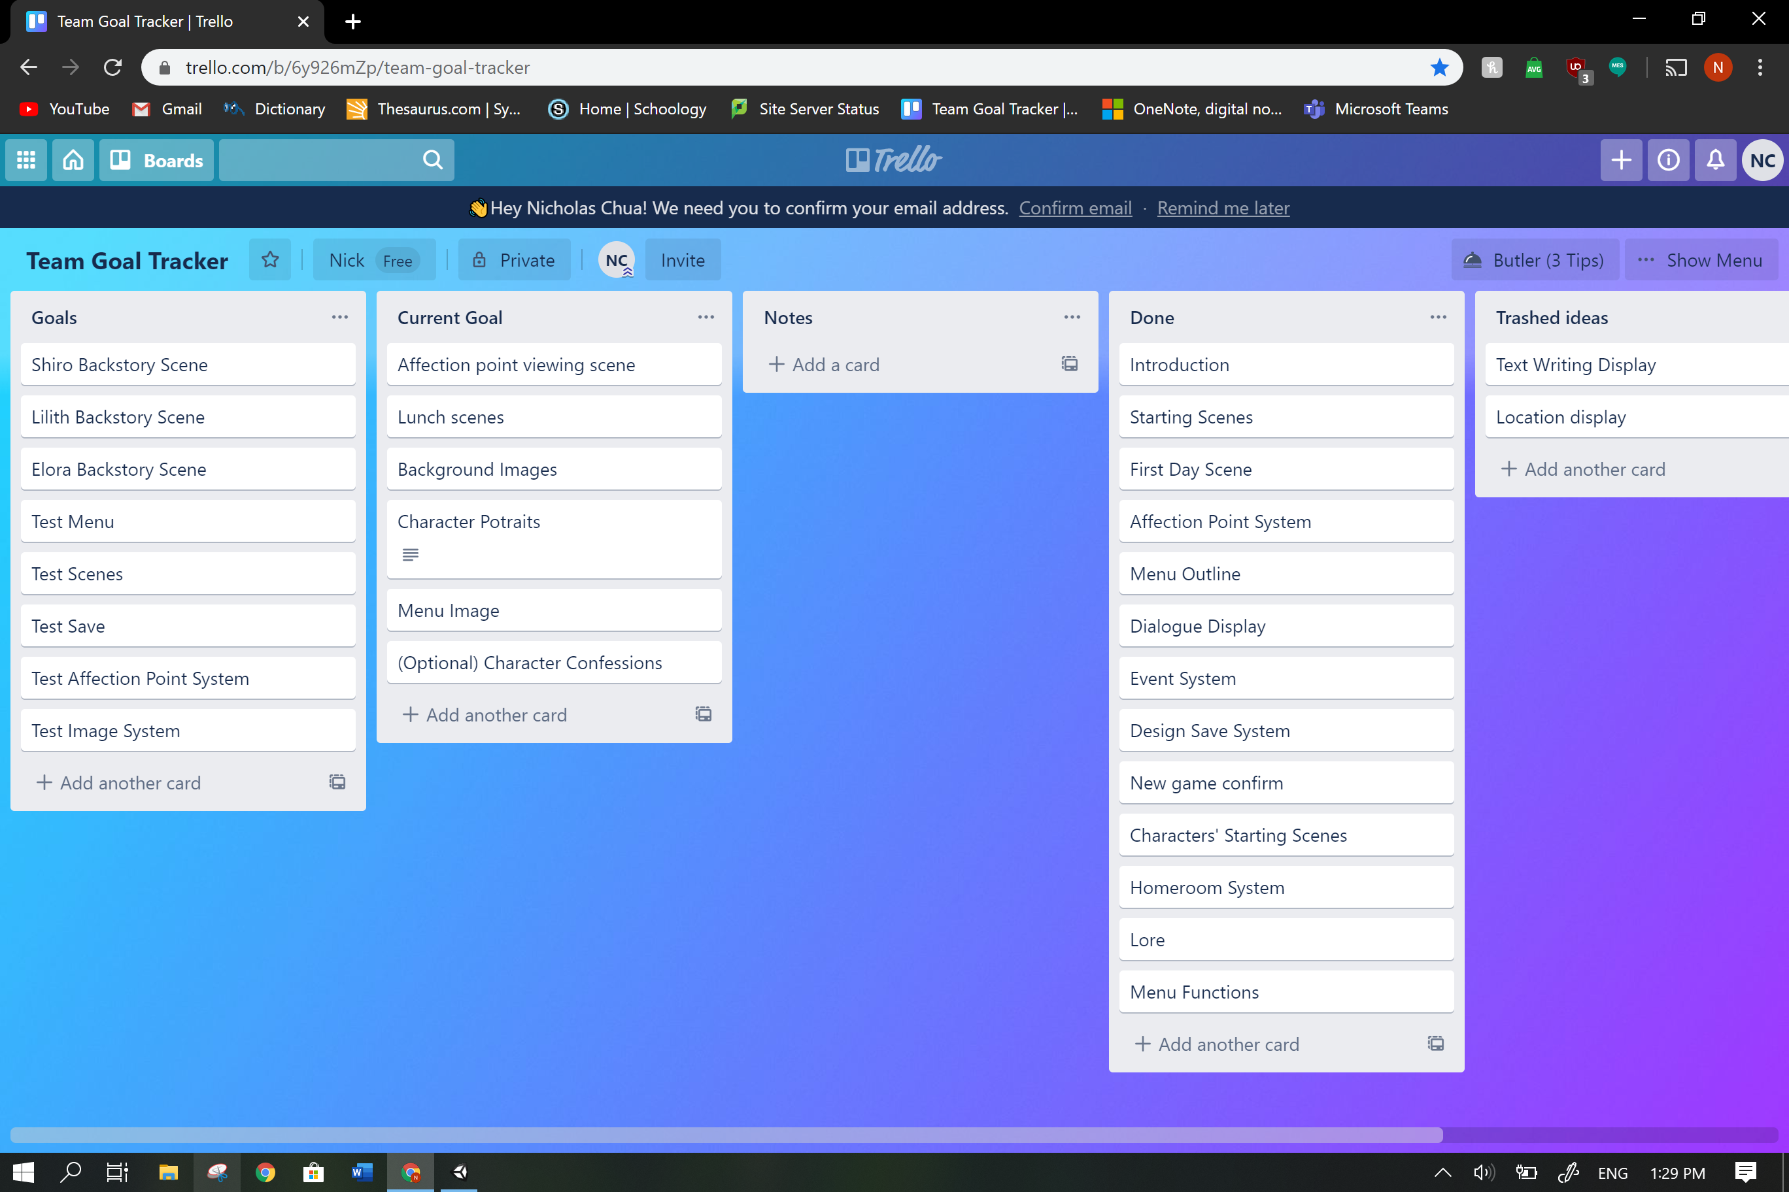

**Feedback and Changes**

“You could probably reverse google search the photos.” **-Veteran Coder Aidan**

To avoid the potential issue of getting sued, I have edited the background sprites to less resemble the original photos they were based off of and changed things to fit the in-game lore.

|  |  |  |
| --- | --- | --- |
| Original | Pixelized | Edited |
| Japanese Classroom" Model #AD#3D Classroom#Japanese#quot#Interior ... |  |  |

Original from <https://www.assetstore.unity3d.com/#!/content/71392?aid=1101l3b93&pubref=3D>

“Maybe you could make a lore page for it like ‘Mass Effect’.” **-Veteran Coder Aidan**

A lore page was added to the menu and expanded upon.

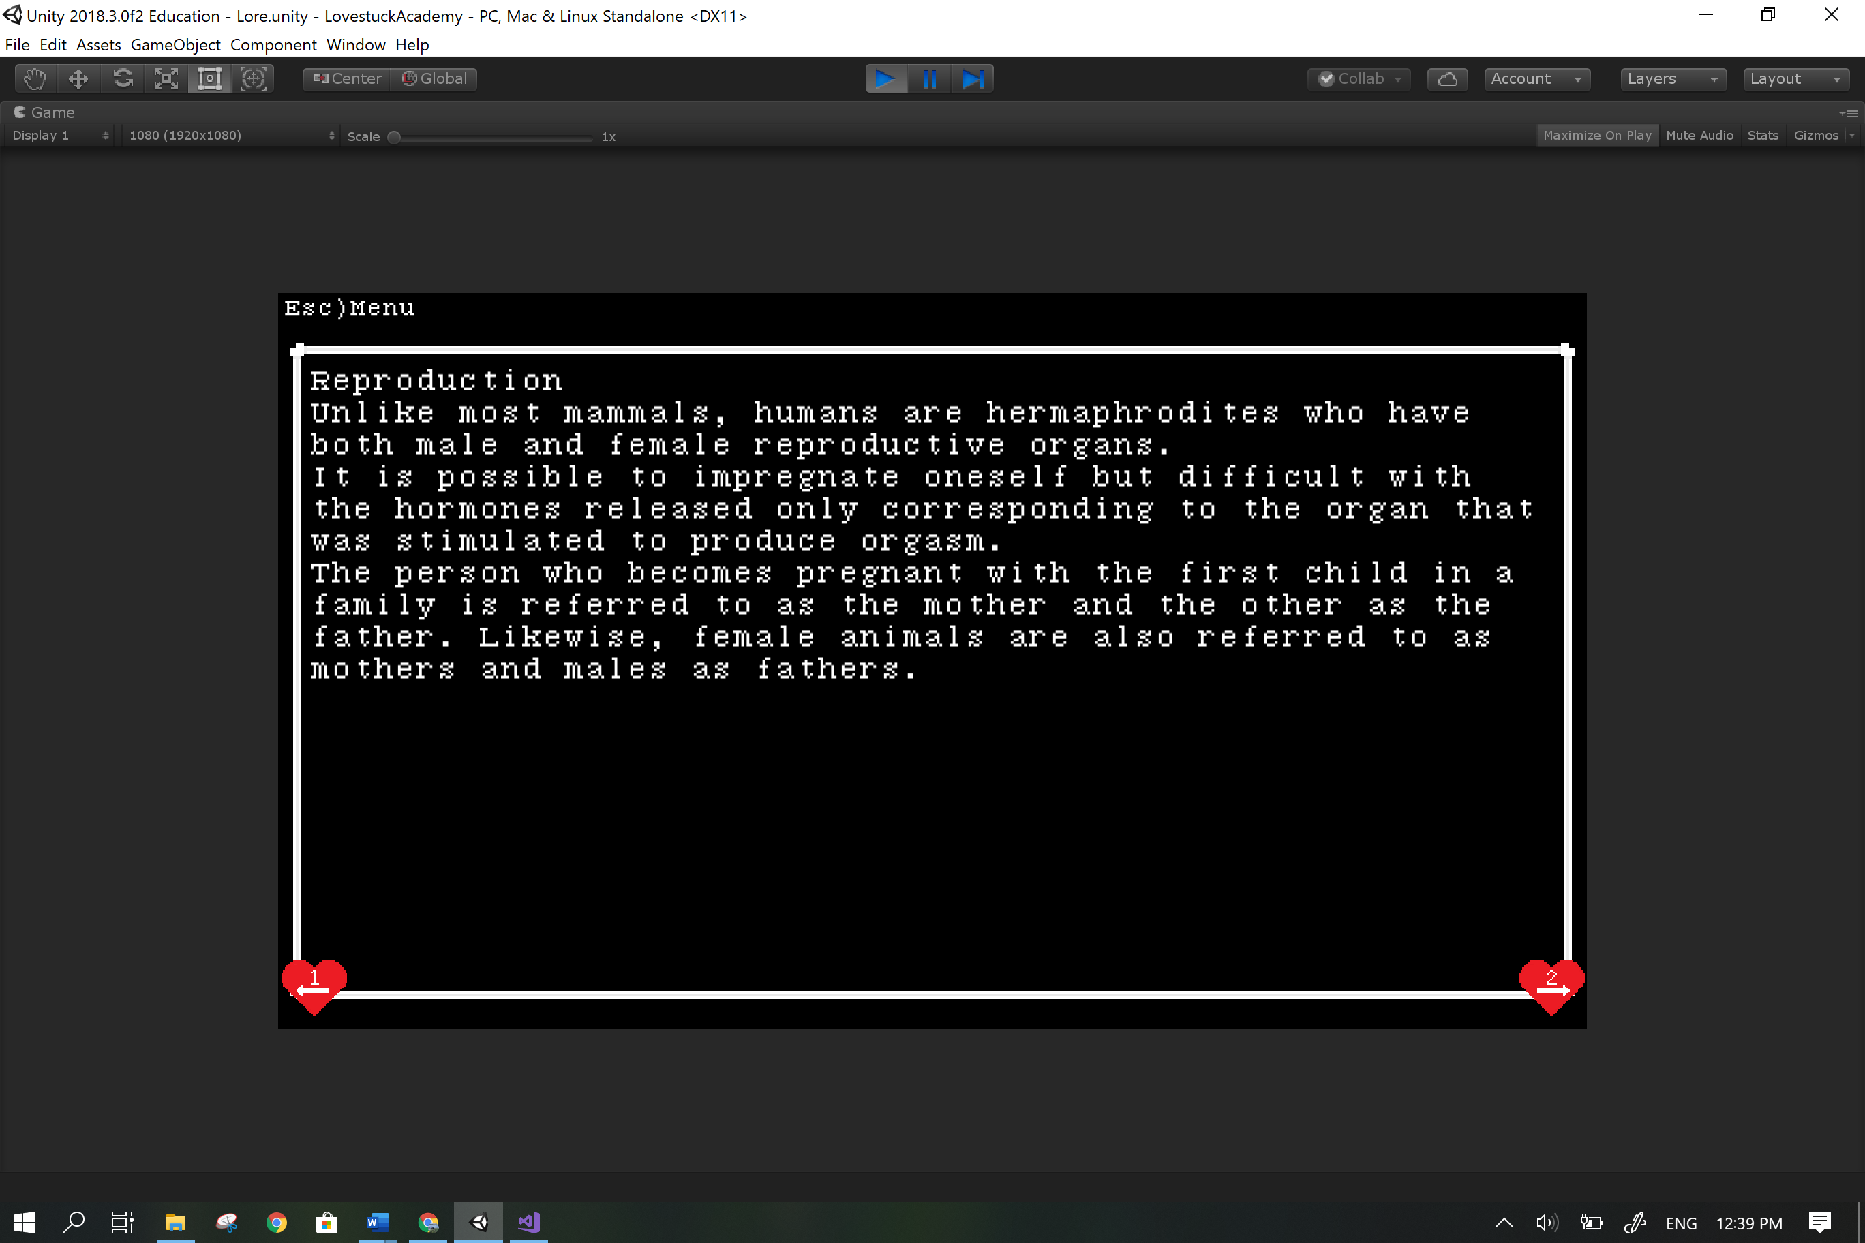

“I went to character affection menu and I couldn’t get back to main menu.” **-Man of Taste Fred**

Wrote code to return to the menu by pressing the esc key.

“What’s the next button for the text, Spacebar? 1?” **-Man of Taste Fred**

Overhaul the system to progress with space instead of one which means removing all the hearts with one on them, adding the instruction at the beginning and altering most scripts as well as retesting it.

“I CAN’T KEEP TO MYSELF WRYYYY.” (context = option in the game) **-Man of Taste Fred**

Code for the option did not exist at the time and so it was written.

“Ketchup girl is also bugged’” **-Man of Taste Fred**

Made the image system a child of the text system so that images no longer covers the text boxes.

“So it’s not sexist.” **-Me**

“’With the appearance of a woman.’” **-A Friendly But Not Pushy Person Who Knows A Bit of Japanese (potentially a lot with how fast she reads it) Hannah**

Removed the text “With the appearance of a woman.” To avoid a feeling of immediate discrimination for women and also so no one can use that quote against me.

“Whirling sounds kinda violent for the atmosphere.” **-Literal Literary Legend Lisa**

Changed “whirling” to “gently flowing.”

“Why do people keep saying Eli? It’s Ellie.”**-Me**

“Because that’s how you say it and Ellie is ‘E’ ‘L’ ‘L’ ‘I’ ‘E’.”

Changed all “Eli” to “Ellie.”

**Personal Changes**

Text system was initially made using a queue and array based off of the system from <https://www.youtube.com/watch?v=_nRzoTzeyxU> where a queue would load elements form and array and then be dequeued to return the text to the text display but the system could not function as so was replaced with another system built solely on arrays which is simpler and functions well.

The sudden changes in scenes felt jarring so extra text was added in between scenes to ease the flow of gameplay.

**Proof of Multiple Iterations**

<https://github.com/NickTheNicker/LovestuckAcademy>

**Save 8**

Scenes lack images, text boxes can’t display text and very little code has been written.

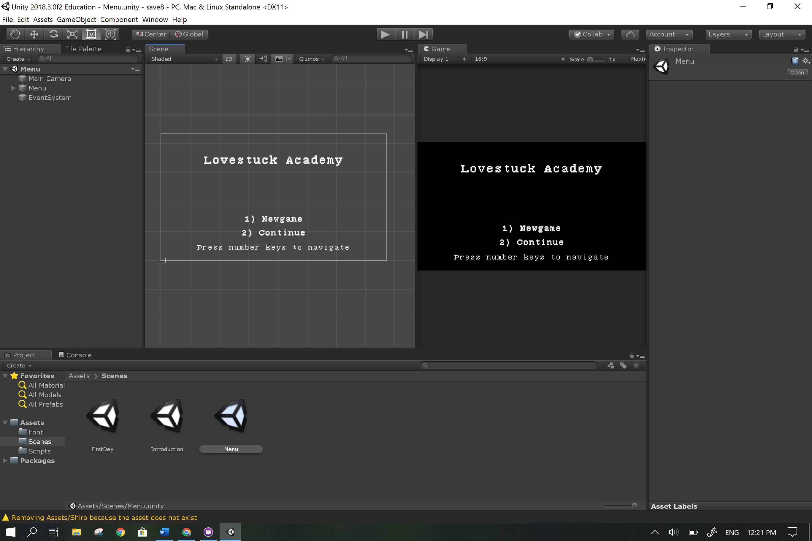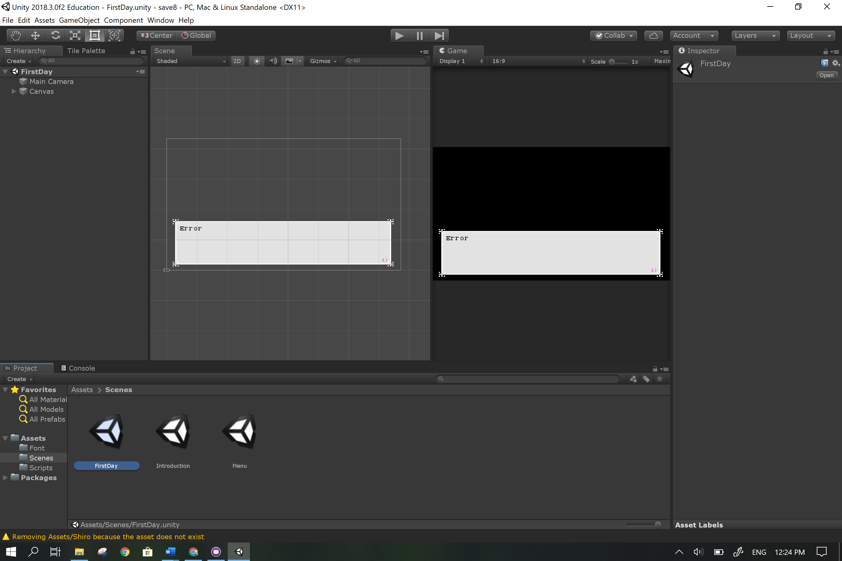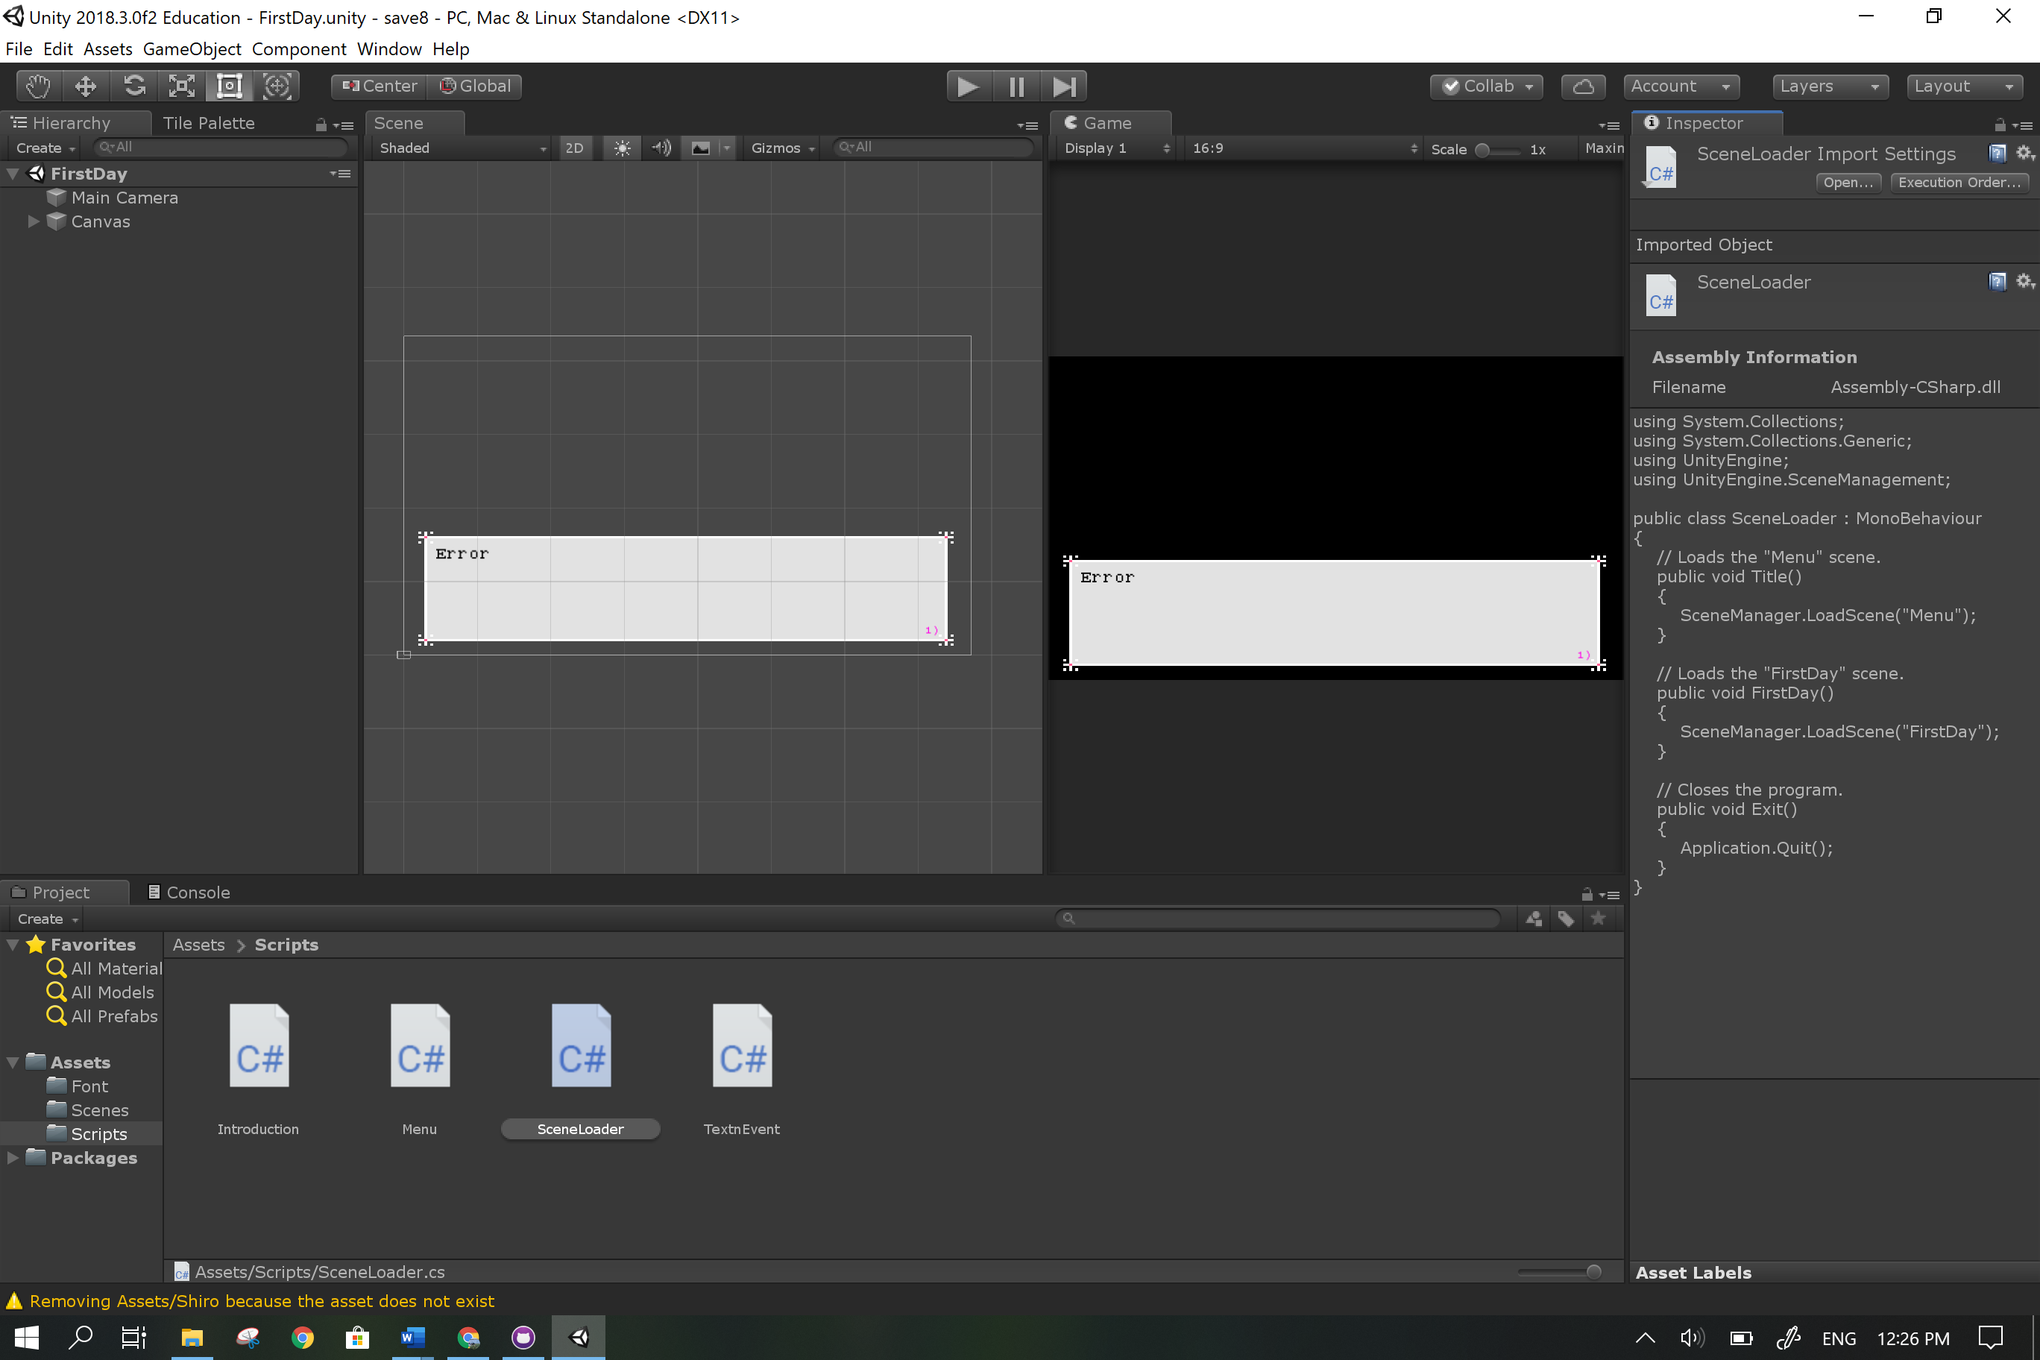

**Save 18**

Scenes still lack images; text boxes display text and can switch pages by pressing the 1 key. Code is complex: a large number and variety of values are used in the many methods that access components and other scripts. Errors are extremely common.

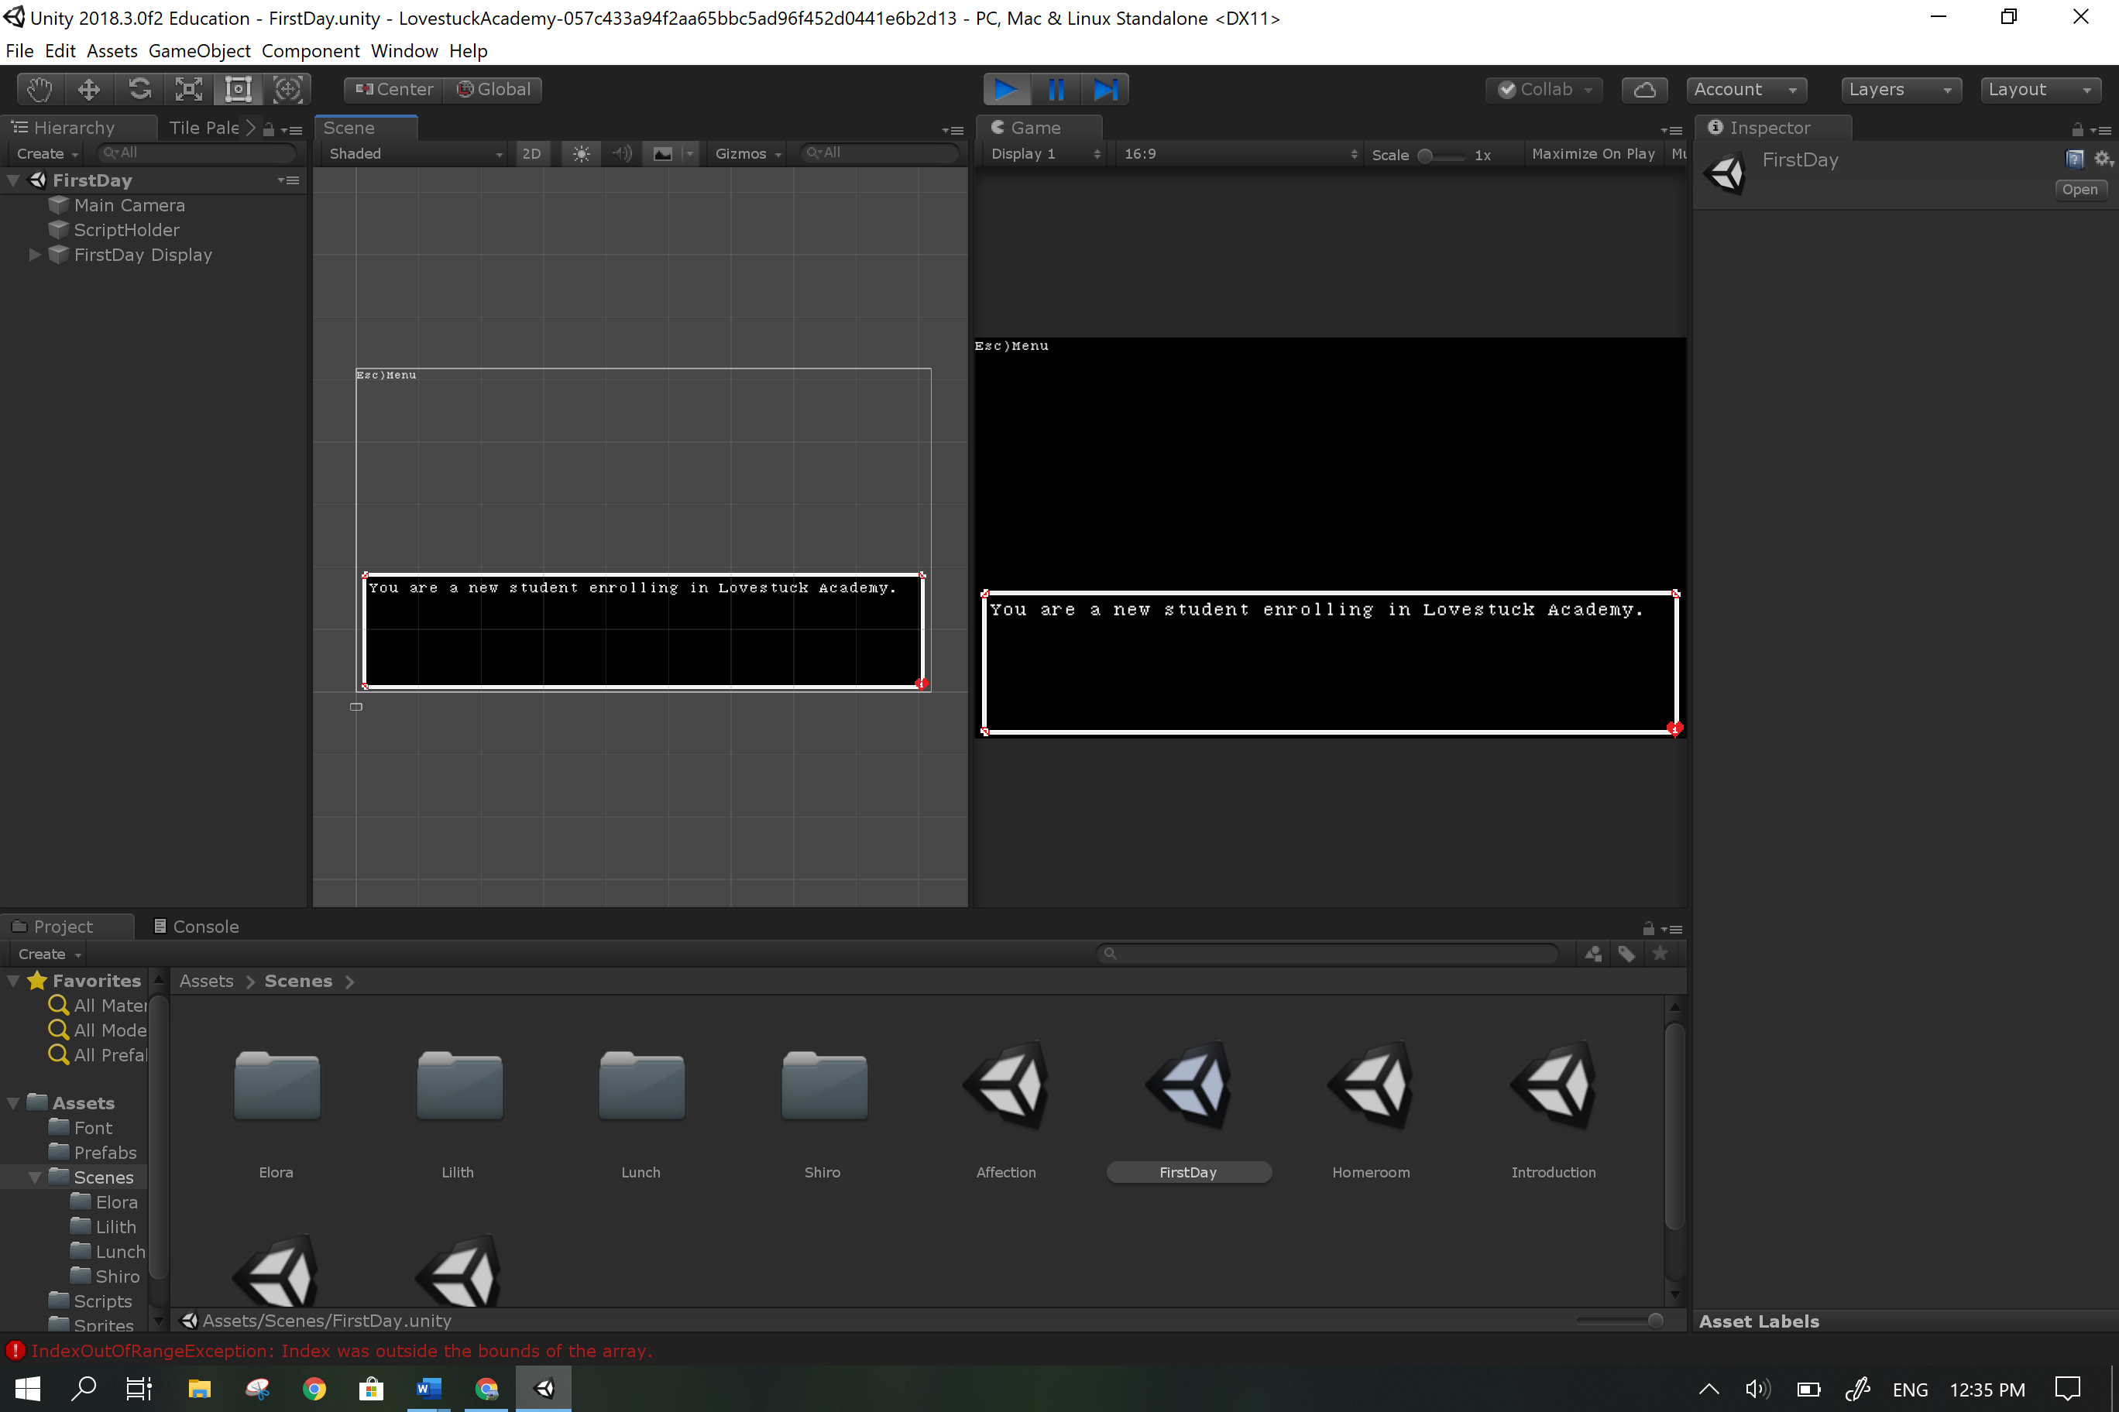

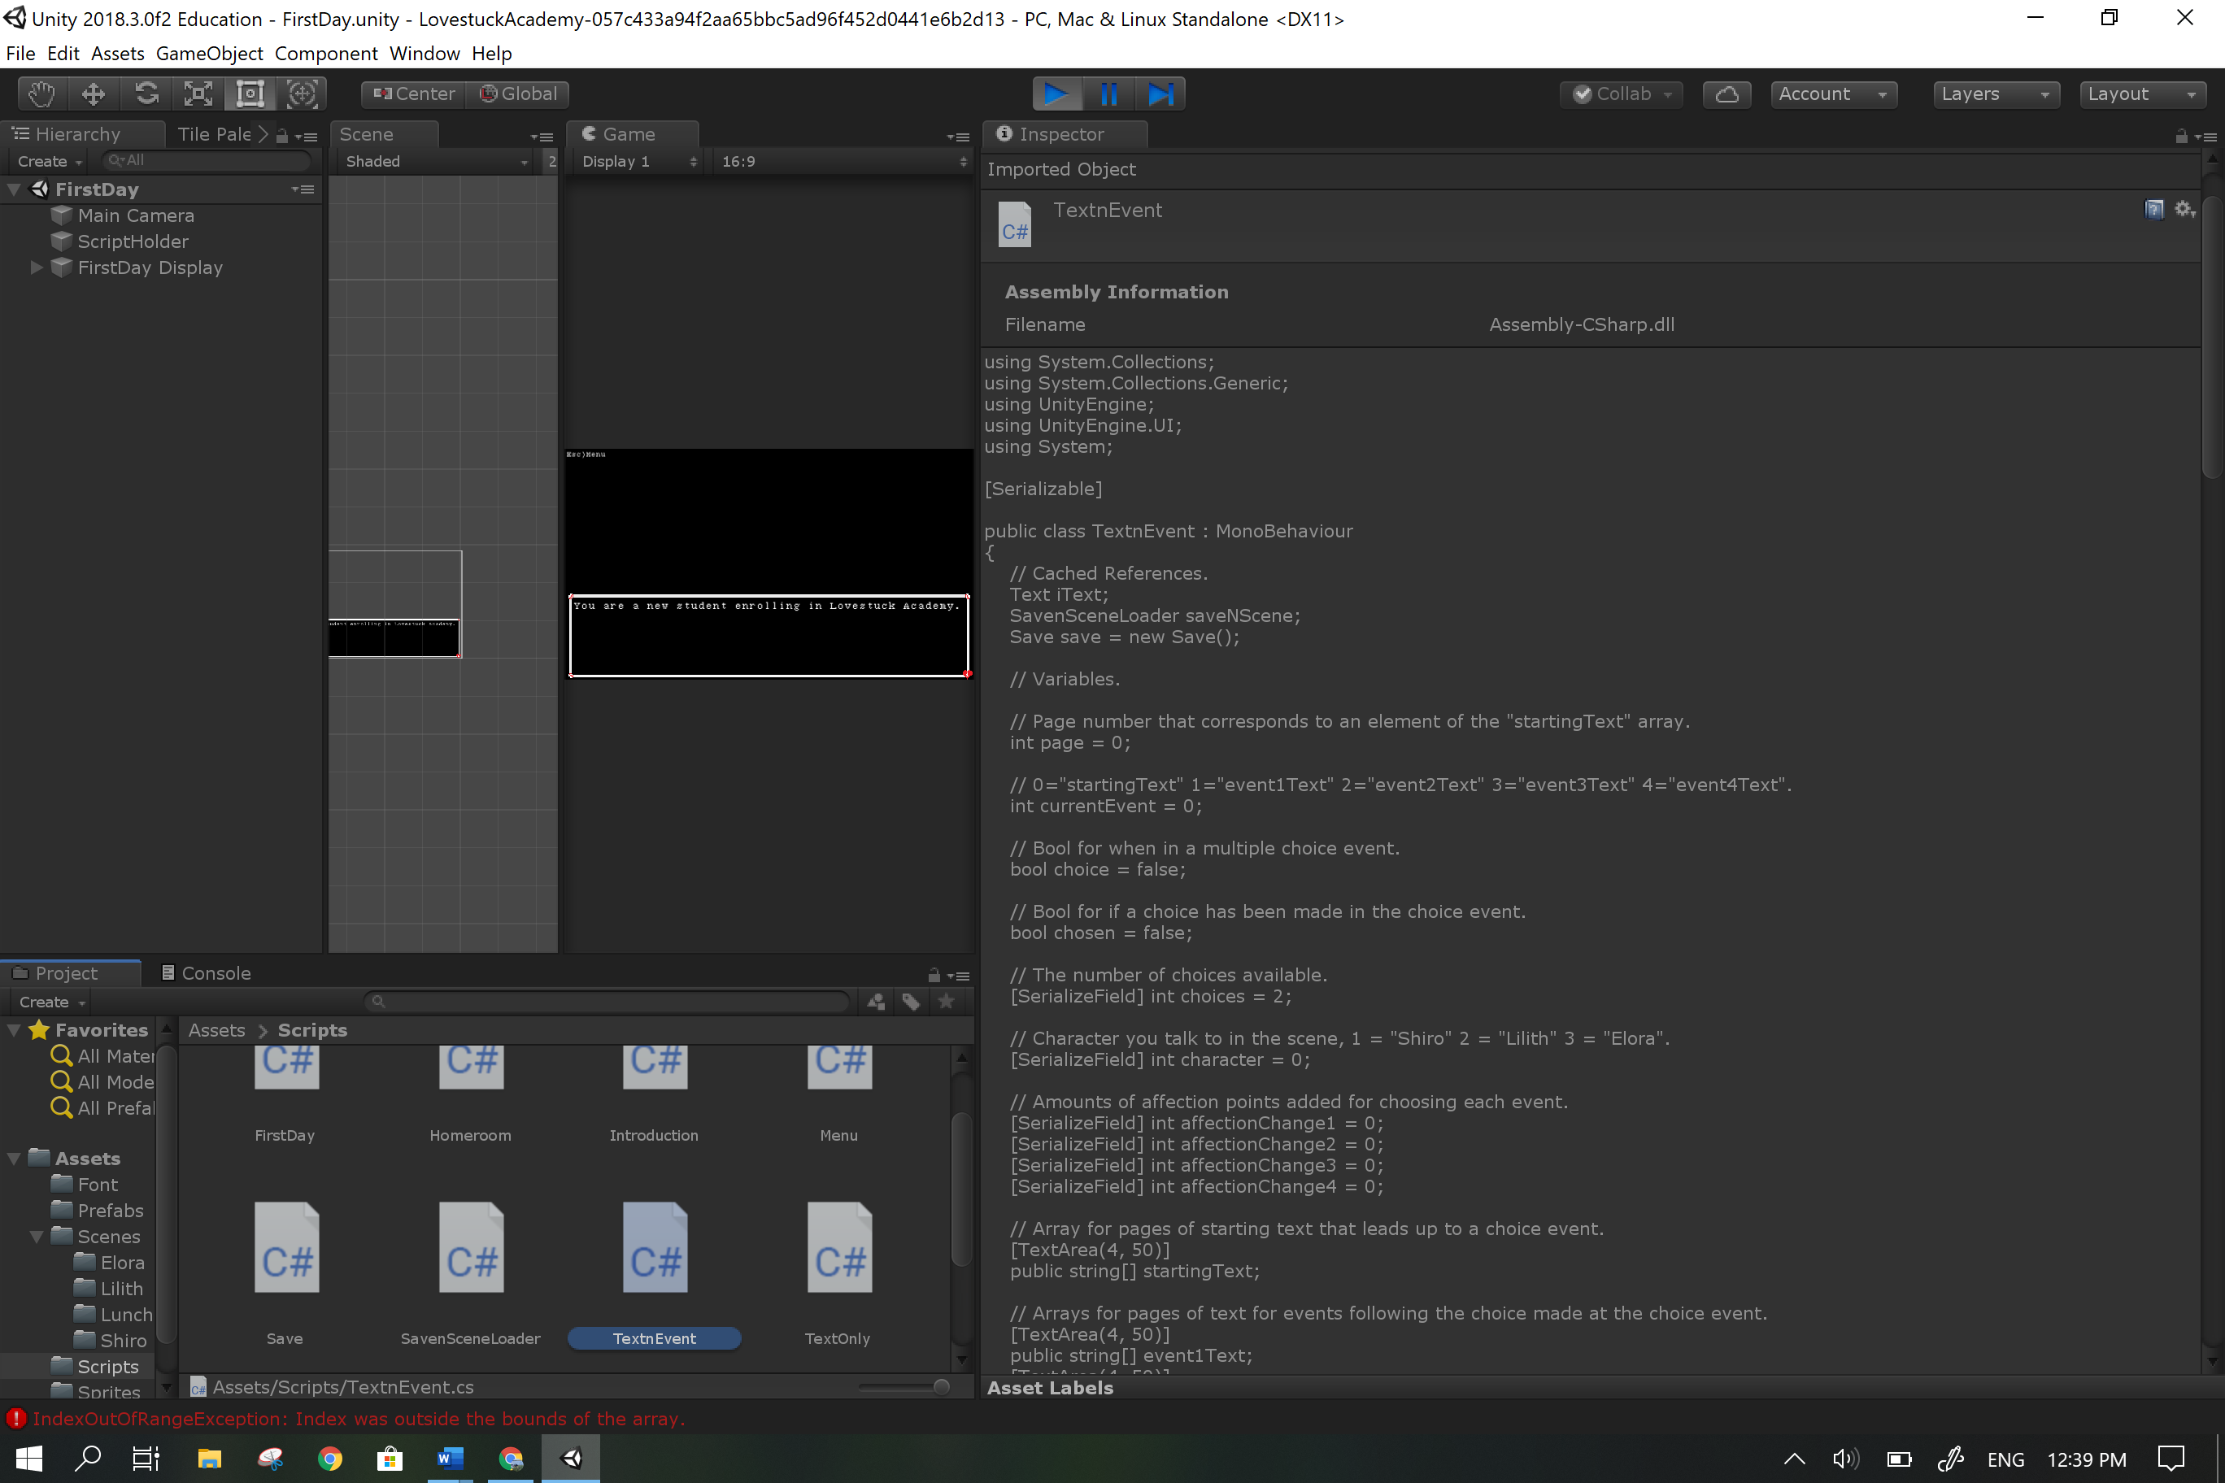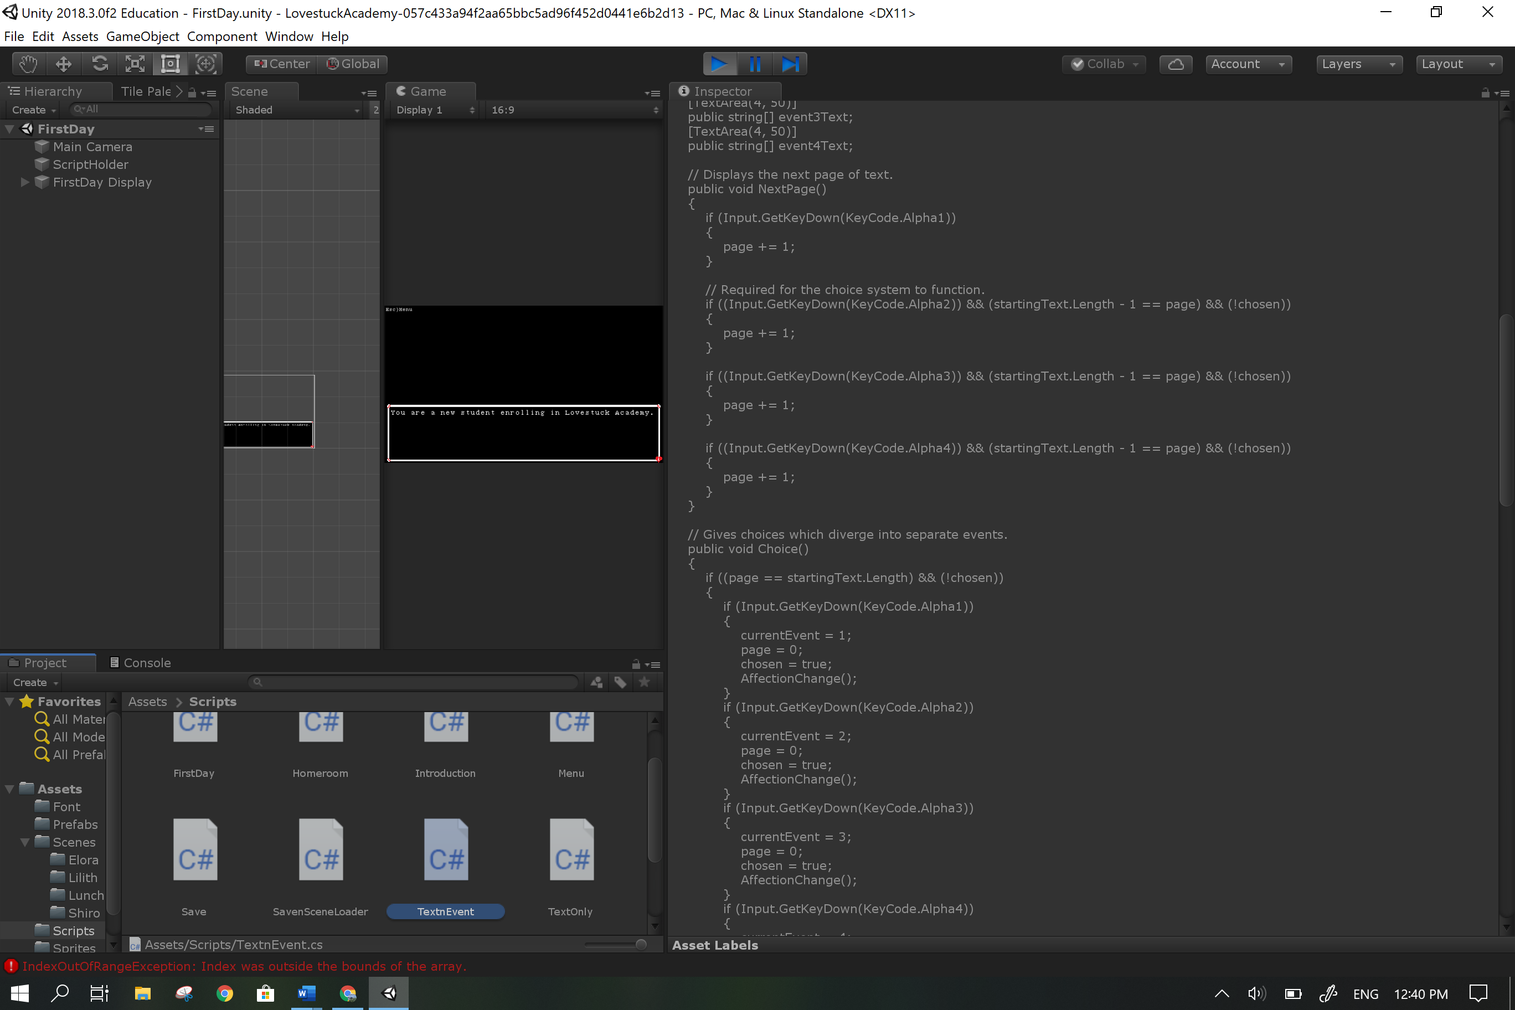

**Save 30**

Scenes have images, save system functions and code is arranged and detailed with comments and complete with no errors.

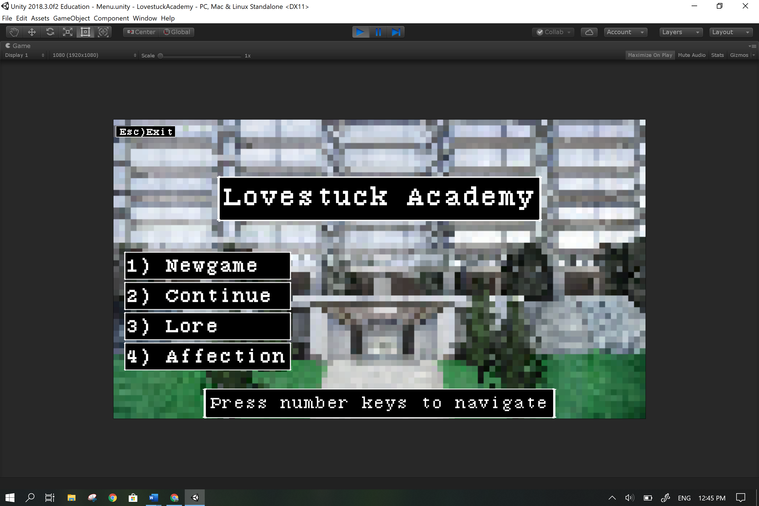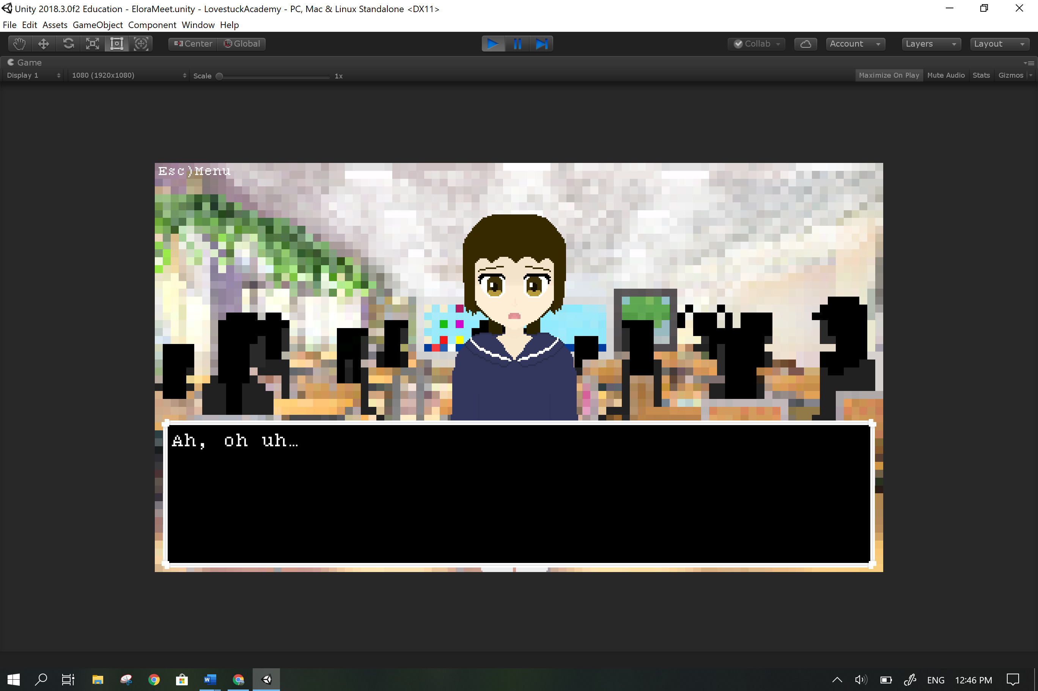

**Relevant implications**

**Social:**

Age restriction of 13+ as one scene talks about sex.

While the nature of the game as a dating simulator might create unrealistic expectations in relationships given the speed at which the heroines get attached to the character, it is expected for the user to distinguish between game and reality when making decisions; therefore, I as the creator am not in any way responsible for any actions the user takes under the influence of the game.

A page of lore hints that every character is Christian and speaks positively about the religion which may offend certain users of different religions but does not directly nor purposely attack any religion.

Every character is a hermaphrodite with female appearances that potentially ostracises female players but less than other dating simulators which have female only love interests.

Everyone is a hermaphrodite because that justifies that this game is not entirely biased towards men but also explores the idea as a side focus to give a new perspective on our own world and what sex and gender differences mean when looking at a world where everyone has the same sex and gender: how do people view animals with two sexes, how would less barriers between people understanding each other feel like or how you refer to parents of the same sex?

The characters have feminine appearances and refer to each other using female pronouns which is catered towards a male audience; however, men have a greater disdain towards any form of intimacy with the same sex but women are more comfortable with that intimacy: girl’s would be more likely to share their feelings and touch each other as a way to show affection.

The game has been noted to be rather esoteric with its references and jokes, that is completely intentional.

Cultural: Nothing in the game should offend any and all cultures but if anything does it was never intended to.

**Legal/Intellectual property:**

Use of the program is completely legal, the user will not break any laws using the program.

Users are free to show footage of the game and borrow assets but must credit me for the sprites and cannot say it is their own work.

All character sprites were drawn by me and bear little to no resemblance to the things I based them off so it would be impossible to copyright claim them.

Background sprites were inspired by real images and designs but altered significantly.

All scripts in the “scripts” folder were written by me except for the referenced code by Josh Browne and Aidan Diprose.

The free for commercial use font was ‘**7:12 Serif Font’** by Christian Munk <https://christianmunk.1001fonts.com/>

**Ethical:**

The program does not harm users, animals and property directly or directly encourage users to harm themselves, people, animals and property.

**Privacy:**

The game does not ask for any personal information from the user The game has no way of recording anything on the user’s computer or through it (cameras or microphones).

**Accessibility:**

Usability/Functionality: The game is meant to be played for recreational use, it is the user’s opinion on how well it carries out it’s purpose but it functions as intended with no observed bugs remaining and improved after user feedback.

**Aesthetics:**

The pixel style of the game gives it a retro feel.

No nudity nor partial nudity.

**Sustainability and Future proofing:**

The code is extensively commented and structured so that all methods and variables are easily understood by whoever wishes to maintain the code. Comments detail the function of the code and the structure ensures a logical flow of information.

**End-user considerations:**

The game is very simple and intuitive with very little mechanics and complexity.

The controls are either shown or given at the start of the game.

Controls not shown, follow standard game control conventions. (Space bar to progress through text)

**Health and safety:**

The game is short but through repeated playthroughs over long periods of time (3 hours or more) the user might suffer from the following conditions:

* sore eyes
* sore wrists
* neck pain
* back pain

The user is also advised not to stare too closely at the screen as that will be bad for their eyes.

**I am not in anyway responsible for the problems stated above.**